Overview
AbCS – Audiobook Collector Scanner, is an Audiobook collector database application with full search capabilities for Titles, Authors, Genre, and Series. AbCS can import audiobook details from the data stored in the ID3Tags of each audio file. The Scan will include all subfolders. The import can scan all standard audio formats. The audiobook data that is collected during the scan are Book Title, Author, Year, Genre, Duration, etc. See Import Tag Table below. You can also manually enter new books and edit existing ones. The Update Window allows the mass addition/update of Series and Genre.

The application is designed to be more accessible to those folks with low vision or that use a screen reader. Colors for background and text that provide sharp contrast without being overall too bright. All fonts used are 14-points or larger. Custom message boxes are used to provide14 point font instead of the default windows message box which uses an 8-point font. All messages and tooltips are also routed to the status bar for screen readers. In addition, most controls and fields have shortcut keys using alt and a letter.
Note: This prototype in MS Access lacks screen reader accessibility. The final version will be likely in Python.

function keys
- F2 – toggles selected/unselected text within a field.
- F3 – From the Audiobook window; move to the search box or if in a keyword search clears the search.
- F4 – Closes the currently open window and From the Audiobook window will cancel edit mode or if not in edit mode will close the application.
- F5 – Refreshes the data displayed in the window. Generally, not required.
- F6 – Cycle focus of the window from Header to Detail, to Footer and application menu. Pressing shift-F6 reverses the order.
- F8 – When the cursor is in Author, Title, Series, Genre collection fields opens the associated window for that item.
- F9 – Pressing from the Audiobook Window Open the Import Windows. Pressing F9 from the Import Window is the same as pressing the Import button.
- F10 – move focus to the MS Access ribbon menu.

Shortcut keys
Throughout the application shortcut keys, Alt key followed by a single letter, are used to provide quick access to fields, buttons, and combo boxes. These keys are denoted by an underscore on the letter. E.g. To access the Menu combo box on the audiobook or import window pressing alt-m will move to the Menu combo box.

The Menu located on the Audiobook window allows for keyboard access to other parts of the application. Pressing alt-m to move to the menu followed by the first letter of the menu item followed by enter is the same as choosing an item from the dropdown menu.
E.g. alt-m I – show the Infor/about message box.

Using the Application
When the AbCS application starts a splash Window appears displaying the name of the Database and total titles, author, etc.

The first time the application starts, if there is no data in the application or on the Import list a message box is displayed. Select Import to scan audiobooks located on the computer or select New to enter data manually. If items exist in the database, then the Audiobook Window (main Window) is displayed.

Audiobook Window (main Window)
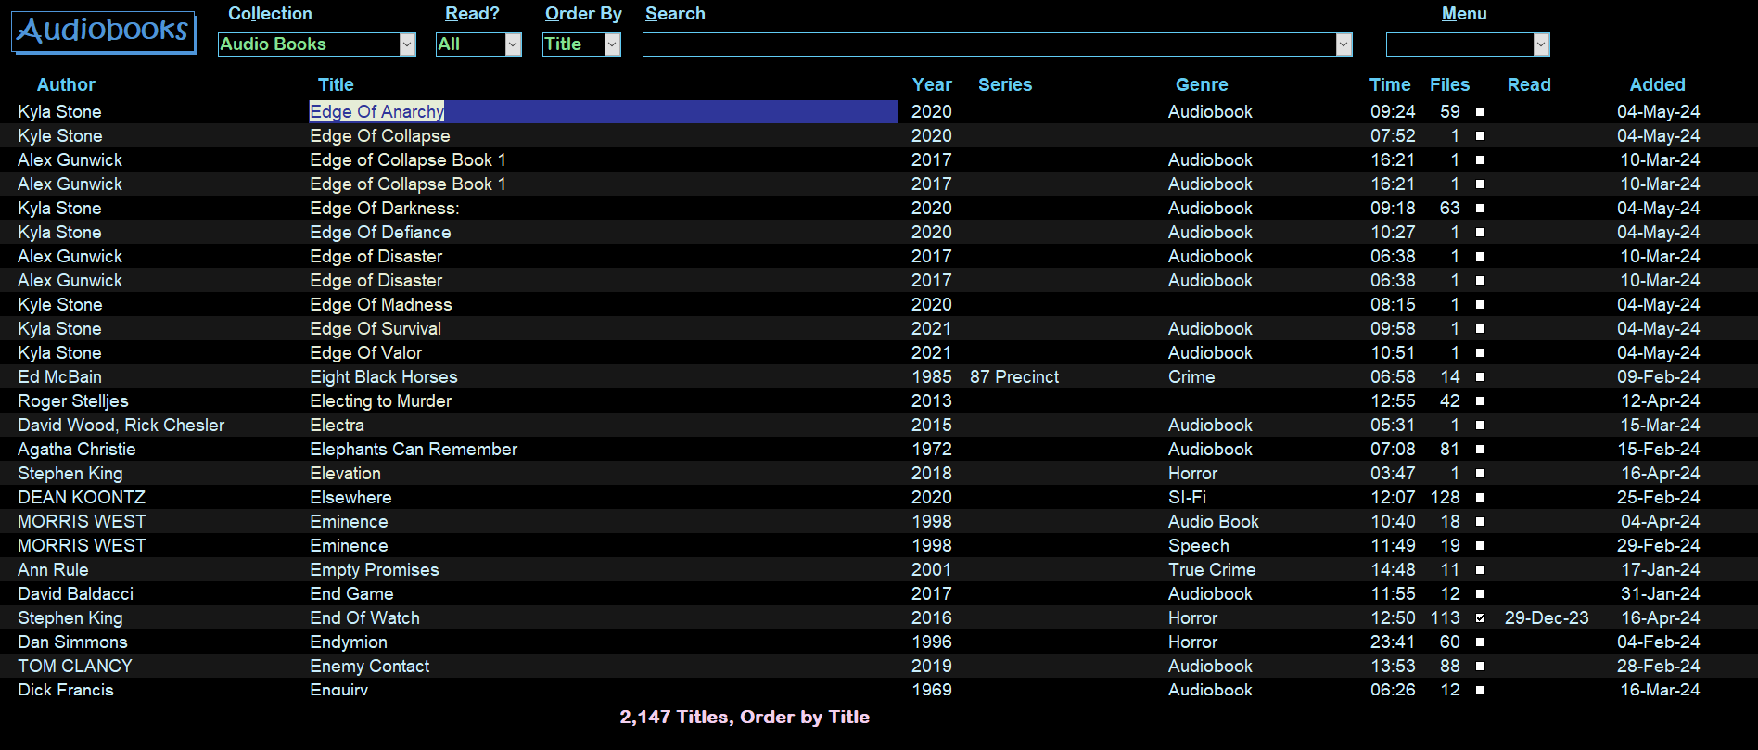

Audiobook Window Header
Five combo controls and one text box, left to right.
- Collection alt-l - if multiple collections exist this allows you to Switch between them or all Collections. Pressing F8 or double-clicking will open the Collection Window.
- Read? alt-r – Allows filtering of books by All, Read, and Unread. Only books matching the selection are displayed.
- Order By alt-o Change the sort order. And search scope. choices are:
- Title – search Titles, sorted by Titles.
- Author – search Authors, sorted by Author, Year, Title
- Genre – search Genre, sorted by Genre, Title
- Series - search Series, sorted by Series, Year, Title
- Search alt-s or F3 – Search will move to the first item on the Window. Only the current Collection is searched unless All is selected for Collection.
- Enter text in the Search box, it will auto fill as you type, if the item exists.
- Or press the down arrow on the Search box or press alt-down-arrow to display the list of items. The list selector bar will move as you type. Press Enter to select the item. The focus moves to the first records that match the selection.
- To do keywords search enter an = “equals sign” followed by a word or phrase to search within an item. Unlike the search above only records containing the search phrase are displayed. The search result is cleared when a new search, pressing F3 or changing the Order By combo boxes. NOTE: The equal “=” is not required but prevents the combo box from automatically updating as matches are found in the database.
- Menu alt-m – Combo box with ten options
- Import - opens the import window.
- New Title -opens the detail screen for data entry.
- Backup/Restore - See below for details.
- Authors, Collection, Genre, Series – each of these items opens their respective windows.
- Show Duplicates – Duplicates are those titles having the same Title, Author, Year and Collection. The application checks for duplicates when adding records from the import. However, duplicate can occur by manual additions or edits. All functions such as Delete, Update is available in the duplicate view. The duplicate result is cleared by new search, pressing F3 or changing any of the combo boxes at the top of the window.
- About
- Quit
- Selected alt-e – The count of records selected for delete or update.

Audiobook Window detail.
A continuous list with the following columns fields.
Author, Title, Year, Series, Genre, Time, Tracks, Read, Date-added
- When the cursor is located within the Author, Series, Genre field: Pressing F8 or double-clicking will open the respective Windows. If the cursor is in the Title fields pressing enter will open the detail window.
- Title – Enter or F8 or double-click open the Book Details Window for viewing and editing.
- Read – A check box that if click toggles the title as read/unread. Next to that is a date field with a date-picker to the right edge of the field. Either can be used to mark a book as read.
- Pressing the Spacebar when in the title fields toggles between selected or unselected for deleting or updating. The count of Selected records is displayed at the top right of the Window alt-e. The selected records will have a different color than normal items and the title and selected or unselected is echoed to the status bar.

Audiobook Window Footer
The footer section has three buttons and two text boxes.
The buttons are only visible if one or more titles are selected.
- Update – alt-u opens the update Window where you can mass update Series, Genre and if more than one collection exists change the collection.
- Delete alt-d or Delete Key – deletes selected records, a confirmation message will appear. Selected titles and any unmatched Authors, Genre and series are removed.
- Cancel – alt-c or F4 clears any titles that are selected and hides Update, Delete and Cancel buttons.
- Text Box - Number of items e.g., Titles, Authors in current selected by the Order By combo. If a keyword-search, (using an “=” equal”) then it shows the number of books that match.
- Text Box – current sort order

Book Details Window
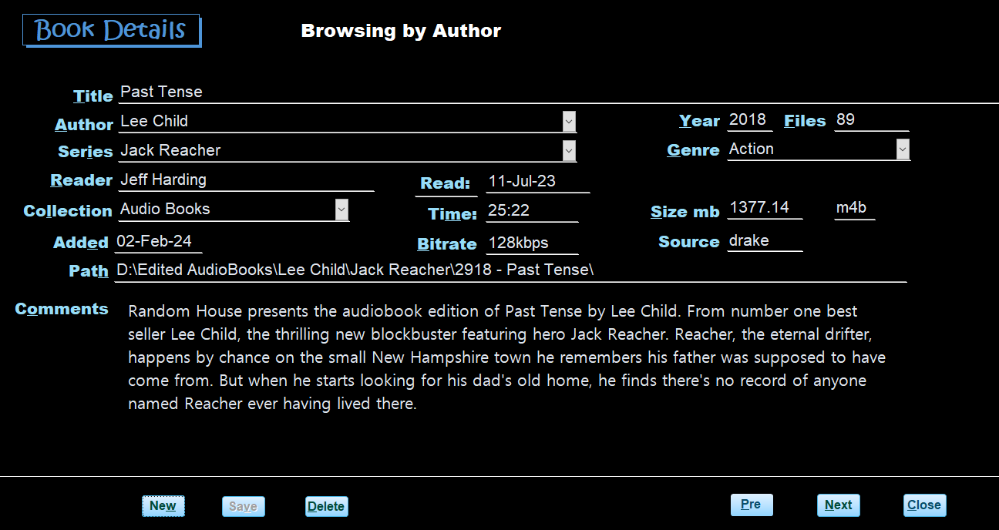

Book Details Window Header
One text box displays the current browsing selection e.g., Title, author which was set in the Audiobook Window.

Book Details Window - Details
Single Window with fields laid out in eight rows and three columns all fields are textbox unless stated otherwise.
- Row1 – title alt-t
- Row2 – Author alt-a combo of all authors. F8 or double-click to open list.
  - Year alt-y – 4-digit year the book was published.
  - Files alt-f - number of files
- Row3 – Series alt-I – combo of all Series. F8 or double-click to open the list.
  - Genre alt-g - combo of all Genre. F8 or double-click to open the list.
- Row4 – Reader alt-r
  - Read - (date read has date selector)
  - Returned – date returned (only visible if the collection’s Borrowed field is checked).
- Row5 – Collection alt-l
  - Time alt-m hour and minutes
  - Size alt-s – in MB
  - File Format – Mp3, etc.
- Row6 – Added alt-e
  - Bitrate alt-b recording quality in kbps
  - Source – windows user-id of the window’s user id used to do the import.
- Row7 – Path alt-h – Location of book when imported. F8 or double-click to open the path in Windows File Explorer
- Row8 – Comments alt-o – comments such book descriptions, etc. Supports Rich Text formatting such as bold, underline, fonts, color, etc.

Book Details Window – Footer
There are six buttons as follows:
- New alt-w or insert-key – Clears the Window for input. Collection and date added fields are auto filled.
- Save – alt-v – this button is visible when any changes are made to the data in the Window.
- Delete alt-d or delete key – deletes the record being displayed. A message confirming the deletion will appear.
- Prev alt-p or Page-Up move to the previous title.
- Next alt-n or Page-Down move to the next title.
- Close alt-c or F4 – close.

All edits are automatically saved when Close, Next and Prev buttons are pressed.

Update Window
The update Window provides the ability to mass updates to selected books from the Audiobook Window.
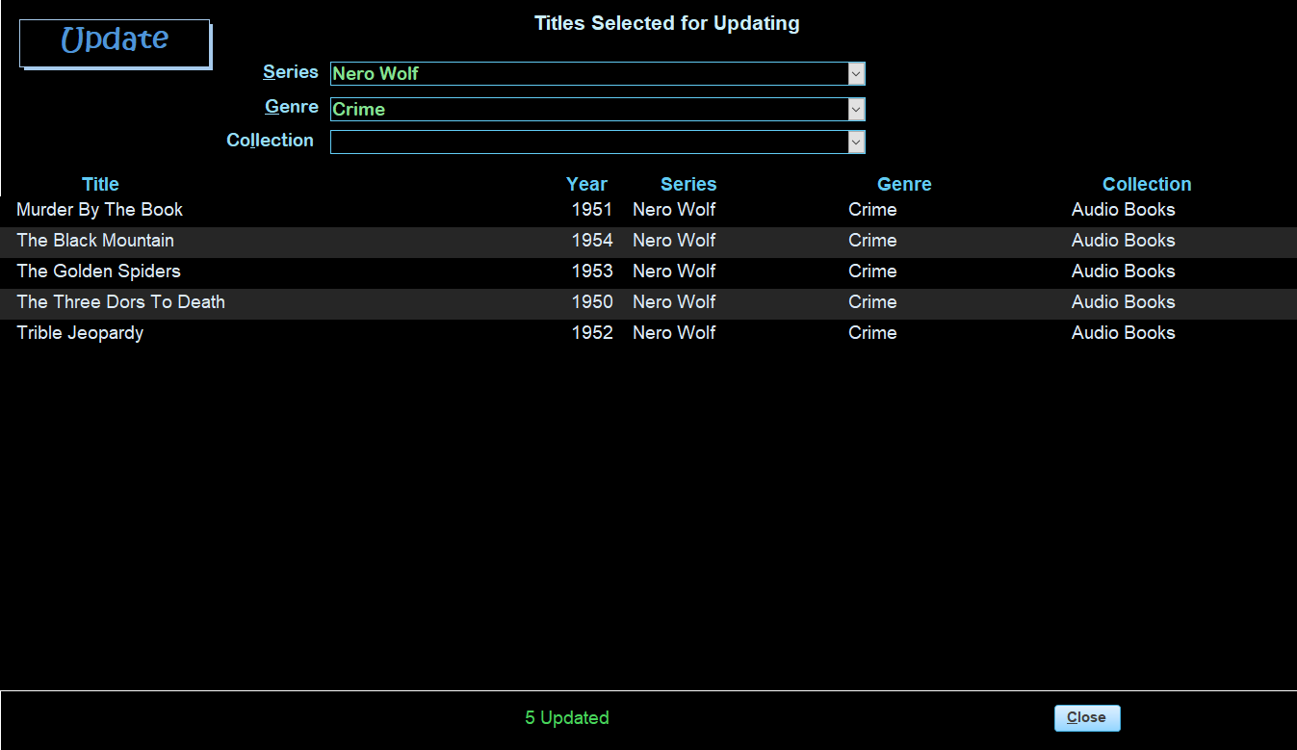

Update Window Header
Three combo boxes Series alt-s, Genre alt-g and Collection alt-l Collection is only visible if multiple collection exists. Select a series and/or genre from the list or enter a new one. Updates occur as soon as a Series, Genre or Collection is selected.

Window Update Details
A continuous list with the following fields, Title, Year, Series, Genre, and Collection
Update Window Footer
Close button alt-c or F4.

Import Window
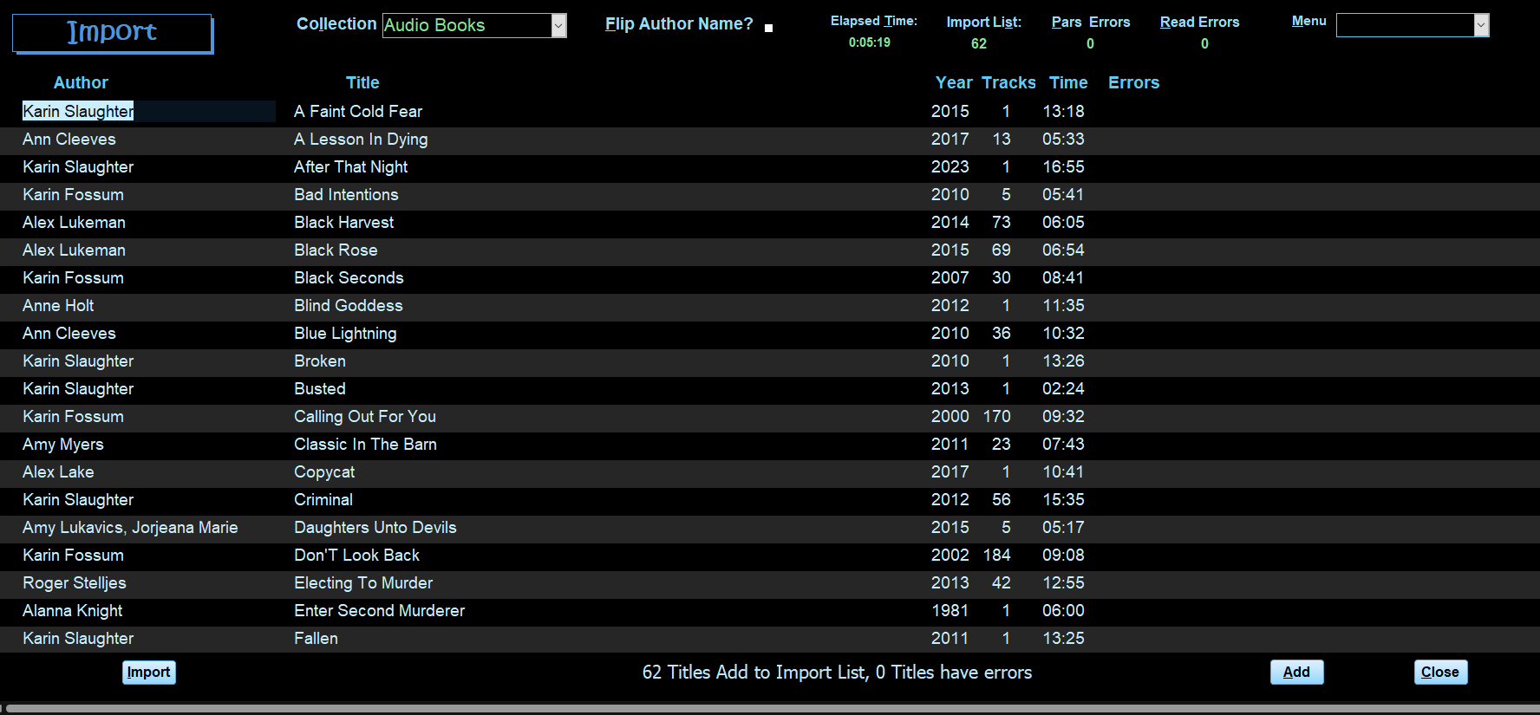

Import Window Header
The Header has the following controls left to right.
- Collection (alt-l) combo choose a collection. If only one collection exists in the database. It will default to that collection. If more than one Collection exists, then choose a collection from the combo box. Pressing F8 or double-clicking will open the Collection Window.
- Flip Author Name (alt-f) Check box flips the author’s name to last, first, default is unchecked.
- Elapsed Time: alt-t time the import took to complete hh:mm.
- Import List: alt-s number of records without errors.
- Parse Errors: alt-p, number of records that have errors, e.g., no author, etc.
- Read Errors: alt-r number of records, caused by corrupted file.
- Menu alt-m – Combo box with four options
- Collection – Open Collection Window to add or edit a collection.
- New Title – open the data entry window.
- Backup/Restore – Open the backup/Restore Window.
- Close the import window and if books exist in the application the Audiobook window will open, otherwise the application will close.

Import Window detail
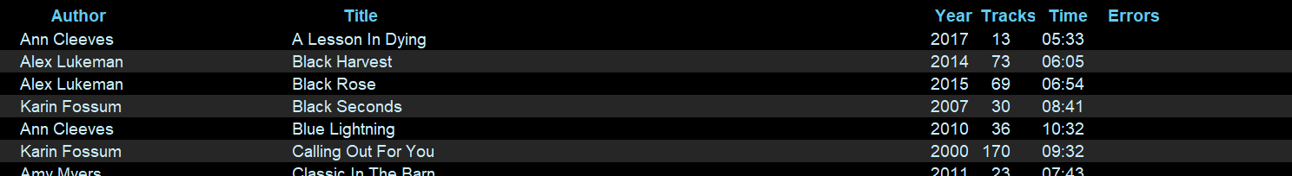
A continuous list with the following fields.
Author, Title, Year, Tracks, Time, Errors. All are plain text boxes.
Pressing Space Bar on a title will toggle the book from add to errors or vice versa.
Pressing F8 or double-clicking on a title with errors will open a detail Window that displays all data. This Window allows you to view/edit the item with errors.

Import Window Footer
Five buttons as follows:
- Import alt-I or F9 – Prompts for a folder to scan. All subfolders are scanned for tags. The prompt is a normal windows explorer dialog box. Select folder and click OK.
- Export alt-x – Exports a list of errors to a standard spreadsheet file.
- View alt-v – Open a detailed view of the book with errors, or F8 when cursor is in the title field.
- Add alt-a - Add the records without errors to the database.
- Close alt-c or F4 - close the Import Window. If there are no audiobooks in the database, the application closes. If audiobooks do exist, the Audiobook window will open.

Import Detail Window
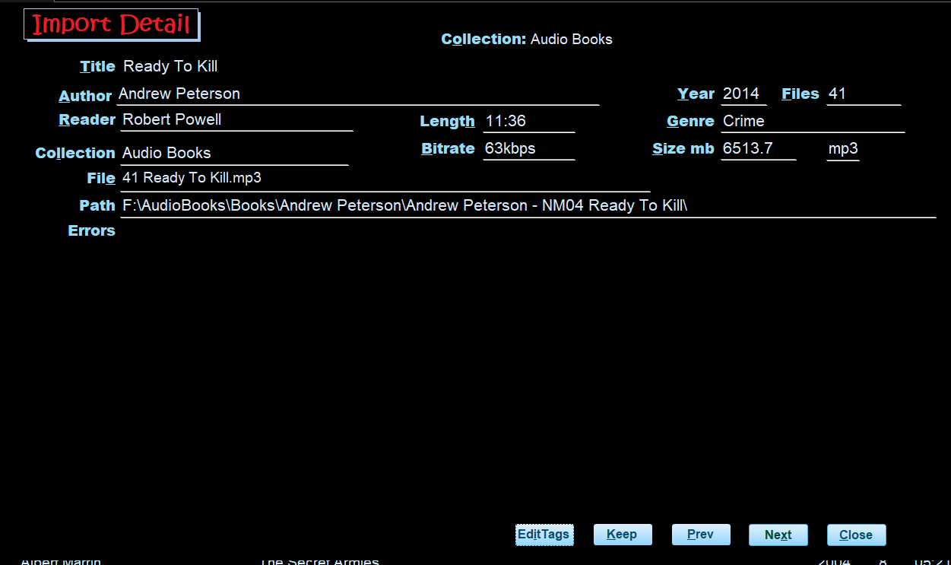
The data in this window is fully editable thus can be changed with no edits.

import Detail Error Header
Current Collection

import Detail Error Detail
Single Window with fields laid out in seven rows and three columns all fields are textboxs.
- Row1 - title alt-t
- Row2 -Author alt-a
  - Year alt-y - year the book was published.
  - Files alt-f - number of files
- Row3 - Reader alt-r
  - Time alt-m hour and minutes
  - Genre alt-g
- Row4 - Collection alt-l
  - Bitrate alt-b
  - Size alt-s – in MB
  - File Format – Mp3, etc.
- Row5 - Path alt-h - The location of the audio files. F8 or double-click to open the path in Windows File Explorer
- Row8 - Errors alt-o – List of the audio files and related errors. See Import Errors Description table below.

import Detail Error Footer
There are five buttons located at the bottom.
- Edit Tag – alt-I –open the audiobook in a tag editor. This button is only visible if Mp3Tag or Tag Scanner is installed on your PC.
- Keep – clears the error flag and moves to the next record with errors.
- Prev alt-p, Next alt-n, or page-up and Page-down move between error records
- Close alt-c or F4 returns to the Import Window.

Importing:
From the Import Window:
- Click the Import button or press F9 or alt-I to start the import. (If any books exist on the import list you will be prompted to ask if you want to keep them. Click Keep alt-k or Delete alt-d .)
  - 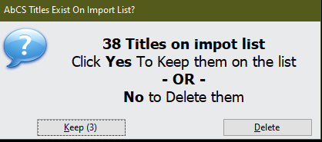
- Select the folder you want to scan and click OK.
- All controls on the window are locked during the import process. If there are many files being scanned a windows Shell Window may appear and it will go away on its own.
- The Importing Status window will display.
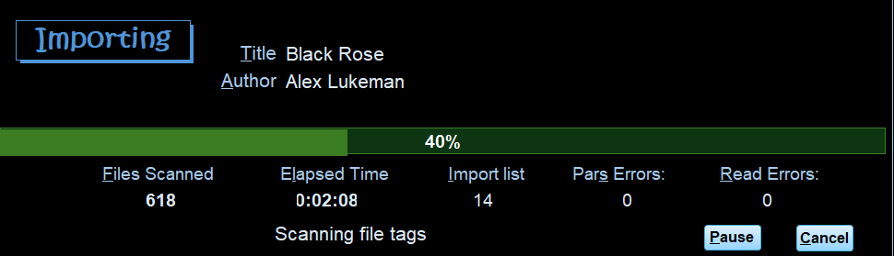
This window displays import progress and counts.
  - Title: alt-t and Author alt-a the current book being processed
  - Error alt-e – only display if the current book has an error.
  - Files Scanned alf-f the number of audio files scanned.
  - Elapsed Time alt-t
  - Import List alt-s – number of books added to the Import list.
  - Parse Errors: alt-p, number of records that have errors, e.g., no author, etc.
  - Read Errors: alt-r number of records, caused by corrupted file.
  - Message box.
  - Pause button alt-p – pauses the import.
  - Cancel alt-c – A message box confirming will be displayed.
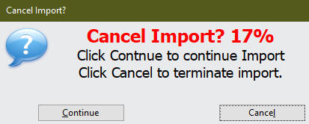

When the import is completed press the Close alt-c button to close the Importing Status window.
The import window will display the books that were imported and any errors.
- Press the View button alt-v – Open a detailed view of the book with errors, or F8 when cursor is in the title field. See Import Detail window below.
- Click Add or alt-a to add all books imported without errors to the database.
- If there are no more books on the import list the import Window will close, and the Audiobook Window is displayed. If errors exists the Import window will remain open.

Collection Window
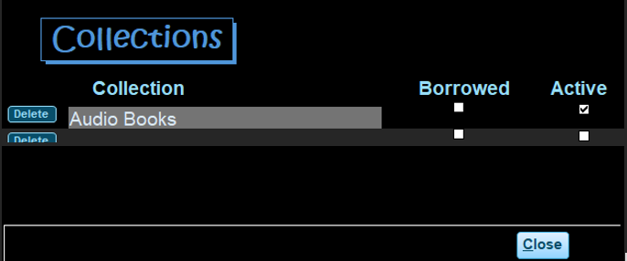
Collection Window Header – no controls
Collection Window Detail
Four controlls
- Delete button
- Collection name
- Borrowed checkbox – If checked the return date field will be displayed on the Detail Window.
- Active checkbox – If checked then the collection is shown in the Collection combo on the Audiobook and Import Windows. To hide a collection uncheck the Active checkbox.
Collection Window Footer – Close alt-c or F4.

Author, Genre, and Series Windows
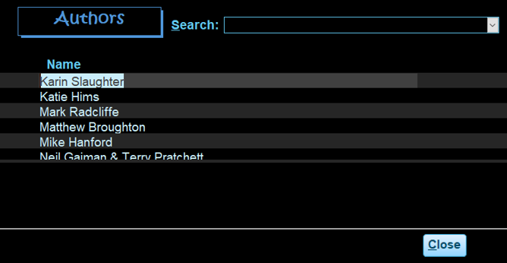
These three Windows are similar with the same controls and layout. They are for making corrections to Author, Series or Genre.
Author Window Header - Search combo box to quickly move to a particular Author.
Author Window Detail - Continuous list Author Name.
Author Window Footer – Close alt-c or F4.
Note: Author, Collection, Genre, or Series cannot be deleted if there are books associated with them.

Backup/Restore Window
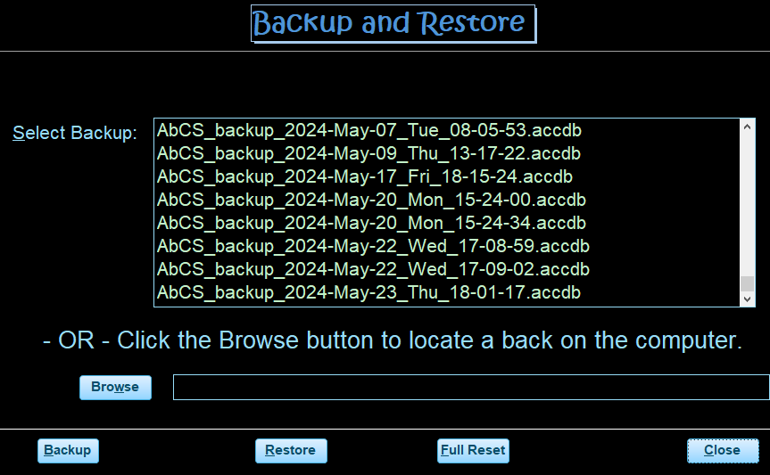
Backup/Restore Window Header – no controls

Backup/Restore Window – detail
- Listbox – list existing backups
- Browse button – to select a backup that is located somewhere other than the default backup folder
- Textbox – Display the name of the backup file to be restored.

Backup/Restore Window – Footer
Four buttons:
- Backup alt-b – creates a backup of the application in the default bacckup folder
- Resore alt-r – Restores the application from a selected backup
- Full Reset alt-f – Clears all data in the application.
- Close alt-c or F4 – Close the Backup/Restore window.

Backup files are names are: AbCS_backup_yyyy-mm-dd_ddd_hh-mm-ss
e.g. AbCS_backup_2024-May-17_Fri_18-15-24.

Import Errors Description
Error messages | Cause / tag issue
Author Blank | Blank tag for Album Artist and Artist tag
Author name in Title | Title contains author name (not always an error)
Author Name is 'Artist Album' | Album Artist and Artist tag are null
Author Name is 'Unknown Artist' | Unknown in Album Artist and Artist tag
Author Name Starts with | Author name begins with non-alphabetic character
Duplicate Author & Title | Duplicates are those records having the same Title, Author, Year and Collection
File not found | The folder/files being scanned have move – usually caused by USB drive being disconnected from the computer.
Read Error | Unable to read the file. Usually due to corrupted tags in the file.
Title Blank | Blank tag for Album is blank
Title in Author name | Book title appears in Author Tag

ID3Tags scanned during import:
Book Data Field | ID3Tag Source
Book Title | Album (13)
Author | Album Artist (237) if empty Artist (13)
Size in MB | TrackSize (1) in kb accumulated if multiple files.
Time in hours & minutes | Track Time (27) accumulated if multiple files.
Release year | Year (15)
Audio Quality | Bitrate (28) in kb
Genre | Genre (16)
Comments | Comments (240 accumulated if different in each file of a book. Scan for “read by”, etc.
Reader/narrator | Composer (243) sometimes contains the narrator/reader.

